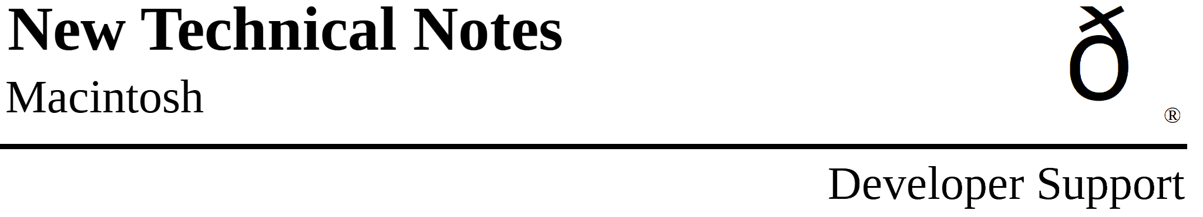

So Many Bitmaps, So Little Time
Imaging M.IM.BitMatToRegion

Revised by: Rich Collyer December 1989
Written by: Rick Blair April 1988

This Technical Note discusses the routine BitMapToRegion, which converts a bitmap to a region, and is available in the 32-Bit QuickDraw INIT and from Apple Software Licensing.
Changes since October 1989: Added trap definitions for developers using the 32-Bit QuickDraw version of this routine without the correct MPW include file.

The following routine is now available to convert a bitmap to a region:

FUNCTION BitMapToRegion(region:RgnHandle; bMap:BitMap): OSErr;

in C:

pascal OSErr BitMapToRegion(RgnHandle region, BitMap bMap);

If you are using the 32-Bit QuickDraw version of this routine without the correct MPW include file, then you need to include one of the following definitions:

Pascal

FUNCTION BitMapToRegion (region: RgnHandle; bMap: BitMap): OSErr;
INLINE $A8D7;

C

pascal OSErr BitMapToRegion (RgnHandle region, const BitMap *bMap)
= 0xA8D7;

Assembly

_BitMapToRegion OPWORD $A8D7

The region will be built so that all one bits in bMap are inside the region and all zero bits are outside of it.

As with all QuickDraw calls which change a region, BitMapToRegion requires you to pass an existing region (originally created by _NewRgn). If the region cannot be built due to an insufficient heap space or a size greater than 32K, then the routine will return an appropriate error code and the region will be empty. If the region would have exceeded 32K, the error will be rgnTooBigErr (-500).

This function is useful for a number of situations where you have (or can produce) a bitmap representing an area. You can use _CalcMask to produce such a bitmap. Once you have a region, you can perform region operations (i.e., _PtInRgn, _UnionRgn, or _InsetRgn) or call _DragGrayRgn, for example.

This call is part of the 32-Bit QuickDraw INIT ($A8D7). If you do not wish to depend on 32-Bit QuickDraw, then you can obtain a version of BitMapToRegion in MPW object format which can be linked into an MPW program, by contacting Apple Software Licensing:

Apple Software Licensing
Apple Computer, Inc.,
20525 Mariani Avenue, M/S 38-I
Cupertino, CA, 95014
(408) 974-4667
AppleLink: SW.LICENSE

If you licensed the older version of this routine, BitMapRgn, contact Software Licensing about receiving an updated version. We recommend you update your application to use the new version as soon as possible.

The new version is now named BitMapToRegion to be consistent with the version in 32-Bit QuickDraw and the MPW interfaces. In addition, BitMapToRegion offers new features. You can now pass a one-bit pixelmap which has been coerced to a bitmap. If you pass a pixelmap which is too large, then you will get a pixmapTooDeepErr (-148) error. You can also pass the portBits of a window, much like you would do with a call to _CopyBits.

There is a potential problem with this routine, since MPW 3.1 include files contain information about 32-Bit QuickDraw. If you want BitMapToRegion to be available on all machines, then you must use the object file from Software Licensing. The problem is that when you compile your application with MPW 3.1 or later, the 32-Bit QuickDraw version gets preference over the object file. You must comment out the routine in the include files if you want to use the object file. If you only care about using BitMapToRegion on machines running 32-Bit QuickDraw, then you need not do anything.

